SIMATS ENGINEERING
ASSESSMENT TOOL 2

COURSE NAME: COMPUTER NETWORKS COURSE CODE: CSA0713

COURSE OUTCOME COVERED
CO2: Configure IP addressing schemes, subnetting, and basic routing techniques
using simulation tool, for efficient network design and topology. (BL3)
Assessment Tool Weightage: 30%

Annexure A
Scenario-Based

Code of Conduct:
I _ A SREENATH(192525119) (Name / Reg No) certify that this submission is my original work
and that I have adhered to the guidelines specified for this assessment.
I understand that any violation of academic integrity rules will result in disciplinary action.

Signature of the student: A SREENATH

1. A newly established Smart Campus is deploying a secure network
infrastructure for its academic and administrative departments. The network
administrator has been allocated the IP address block 192.168.100.0/24. Based
on the expected number of devices, the following subnet masks have already
been assigned:
School of Computing → /25
School of Electronics → /26
School of Mechanical Engineering → /27

As the network engineer, design the subnet allocation by performing the
following tasks:
1. Determine the network address and broadcast address for each
department.
2. Identify the valid host IP address range for each subnet.
3. Calculate the number of usable host addresses available in each subnet.
4. Determine the remaining unused IP address range within the given
network block.
Sol..

1
School of Computing (/25)
Subnetting the first half of the /24 block.
- Network Address: 192.168.100.0
- Broadcast Address: 192.168.100.127
- Valid Host Range: 192.168.100.1 – 192.168.100.126
- Usable Hosts: 126
2
School of Electronics (/26)
Subnetting the next quarter of the block.
- Network Address: 192.168.100.128
- Broadcast Address: 192.168.100.191
- Valid Host Range: 192.168.100.129 – 192.168.100.190
- Usable Hosts: 62
3
School of Mechanical Engineering (/27)
Subnetting the next eighth of the block.
- Network Address: 192.168.100.192
- Broadcast Address: 192.168.100.223
- Valid Host Range: 192.168.100.193 – 192.168.100.222
- Usable Hosts: 30
4
Remaining Unused Range
The leftover addresses after assigned subnets.
- Unused Range: 192.168.100.224 – 192.168.100.255
- This covers a /27 (192.168.100.224/27) and a /28 (192.168.100.240/28)
- Can be allocated to future departments or services
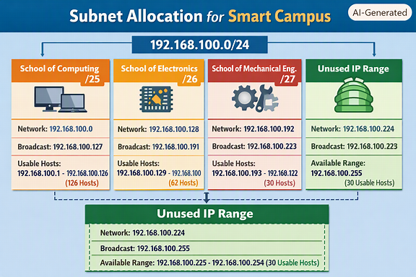
2. A multinational software company is expanding its headquarters and has been
assigned the private IP block 10.10.0.0/16. Different departments require
different subnet sizes based on the number of employees. The network
administrator has allocated the following subnet masks:
Software Development → /24
Quality Assurance → /25
Human Resources → /26
Executive Management → /27

As the network administrator, perform the following tasks:
1. Determine the network address and broadcast address for each
department.
2. Identify the valid range of host IP addresses.
3. Calculate the number of usable hosts in each subnet.
4. Identify the unused IP address range remaining within the allocated IP
block.
Sol..

1️⃣ Network Address and Broadcast Address

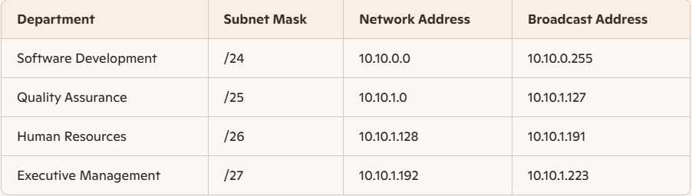

2️⃣ Valid Host IP Address Range
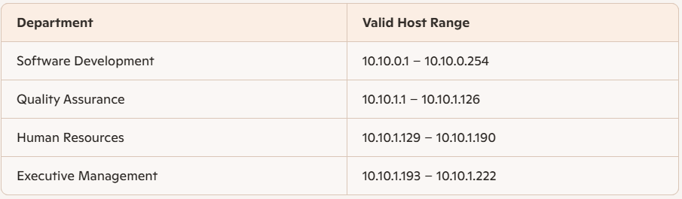

3️⃣ Number of Usable Host Addresses
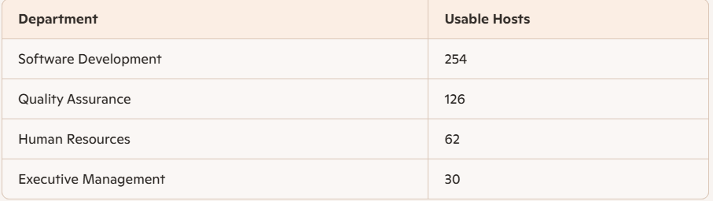

4️⃣ Remaining Unused IP Address Range
- Unused Range: 10.10.1.224 – 10.10.255.255
- Total Unused Usable Hosts: $65,536-\left(254+126+62+30\right)=65,064$

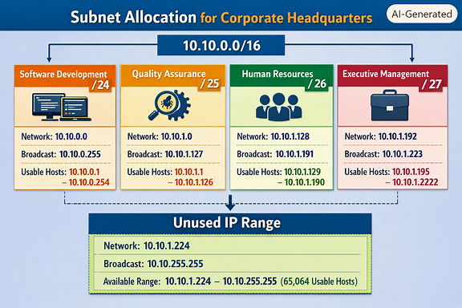
3.A smart hospital is migrating its network infrastructure from IPv4 to IPv6 to
support thousands of connected medical devices and IoT sensors. The hospital
has been assigned the IPv6 network:
2001:0db8:abcd:0000:0000:0000:0000:0000/64
As the network engineer responsible for the migration, perform the following:
1. Convert the given IPv6 address into its compressed notation.
2. Expand the compressed address back into its full hexadecimal
representation.
3. Identify the network prefix using the /64 prefix length.
4. Calculate the total number of host addresses supported within the
subnet.
5. the total number of possible host addresses available within this network.
Sol…

1️⃣ Convert to Compressed Notation
Given IPv6 address: 2001:0db8:abcd:0000:0000:0000:0000:0000/64
👉 Compressed form: 2001:db8:abcd::/64
Explanation:
- Leading zeros in each block are removed.
- Consecutive blocks of zeros are replaced by :: (only once per address).

2️⃣ Expand Back to Full Hexadecimal Representation
👉 Expanded form: 2001:0db8:abcd:0000:0000:0000:0000:0000/64
Explanation:
- Each block is restored to four hexadecimal digits.
- The :: expands to the correct number of zero blocks to make eight total.

3️⃣ Identify the Network Prefix
With a /64 prefix, the network prefix is: 2001:0db8:abcd:0000::/64
Meaning:
- The first 64 bits represent the network portion.
- The last 64 bits represent the host/interface portion.
- This prefix identifies all devices within the same subnet.

4️⃣ Calculate Total Number of Host Addresses in the Subnet
IPv6 addresses are 128 bits long. For a /64 subnet, host bits = $128-64=64$.
$$2^{64}=18,446,744,073,709,551,616$$
✅ Total host addresses per subnet: 18,446,744,073,709,551,616 (≈ 18.4 quintillion)
Explanation: Each subnet can support an enormous number of devices — ideal for IoT and medical sensors.

5️⃣ Total Number of Possible Host Addresses in the Network
Since the entire network block is /64, the total number of host addresses available within this network is the same:
$$2^{64}=18,446,744,073,709,551,616$$
✅ Total possible host addresses: 18,446,744,073,709,551,616
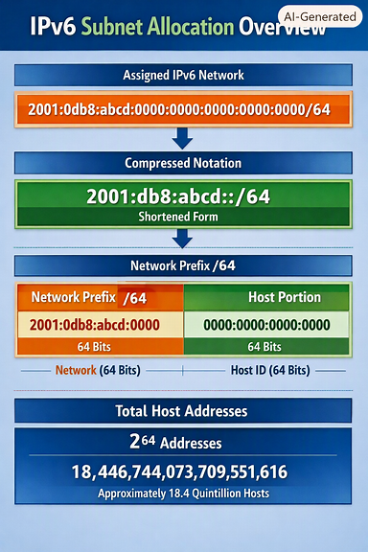
4. An Internet Service Provider (ISP) connects multiple customer networks
through a core router. The router maintains the following routing table entries:
192.168.1.0/24
192.168.2.0/24
192.168.3.0/24
A packet arrives at the router with the destination IP address:
192.168.2.45
As the routing engineer, determine:
1. The destination subnet to which the packet belongs.

2. The matching routing table entry.
3. The next-hop network/interface used to forward the packet.
4. The default route that should be used if the destination does not match
any routing table entry.
Sol…

1️⃣ Destination Subnet
The packet’s destination IP address is 192.168.2.45. Each routing table entry represents a subnet with a /24 mask (255.255.255.0).
- The /24 mask means the first 24 bits (192.168.2) identify the network. ✅ Therefore, 192.168.2.45 belongs to the 192.168.2.0/24 subnet.

2️⃣ Matching Routing Table Entry
The router compares the destination IP with its routing table entries:
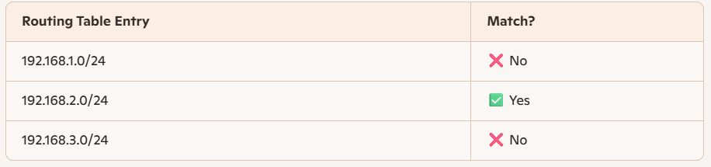
3️⃣ Next-Hop Network/Interface
Each routing table entry typically maps to a next-hop IP or interface. Since the packet matches 192.168.2.0/24, it will be forwarded through the next-hop or interface associated with that entry — for example:
- Next-hop: Router interface connected to the 192.168.2.0/24 network
- Interface: e.g., GigabitEthernet0/2 (depending on router configuration)
✅ Forwarding decision: Send the packet via the interface linked to 192.168.2.0/24.

4️⃣ Default Route (if no match found)
If the destination IP does not match any routing table entry, the router uses the default route (often called the “gateway of last resort”).
- Default route format: 0.0.0.0/0
- Purpose: Matches all addresses not found in the routing table.
- Example:
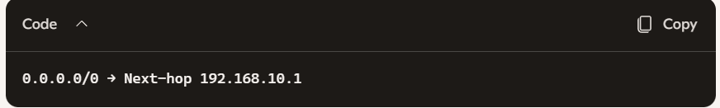
✅ Default route used: 0.0.0.0/0 (forward to the ISP’s upstream gateway)

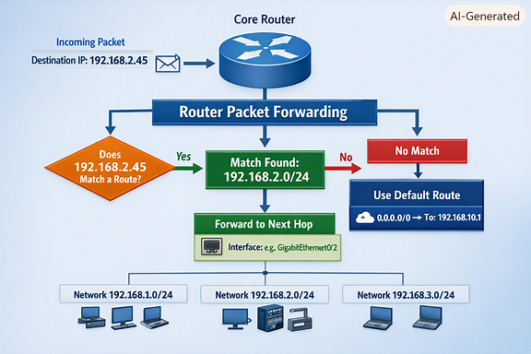
5. A company establishes two office departments connected through a Layer-3
router. The allocated subnet information is as follows:
Administration LAN → 192.168.10.0/26
Finance LAN → 192.168.10.64/26
The router interfaces are configured with:
Administration Gateway → 192.168.10.1
Finance Gateway → 192.168.10.65
As the network administrator, perform the following tasks:
1. Determine the network address and broadcast address for each LAN.
2. Identify the valid host IP address range.
3. Suggest suitable IP addresses for three computers in each LAN.
4. Identify the default gateway that hosts in each LAN should use for
communication.
Sol..

1️⃣ Network Address and Broadcast Address
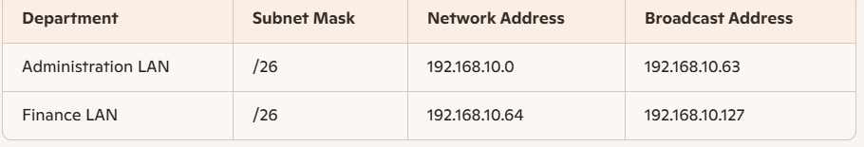
- A /26 subnet has 64 total addresses (from 0–63, 64–127, etc.).
- The first address is the network address, and the last is the broadcast address.

2️⃣ Valid Host IP Address Range
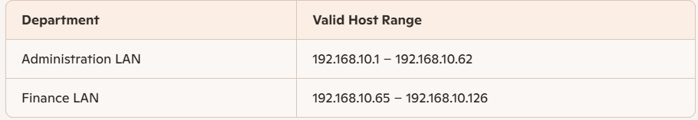
- Host addresses exclude the network and broadcast addresses.
- Each subnet provides 62 usable host addresses.
3️⃣ Suggested IP Addresses for Three Computers
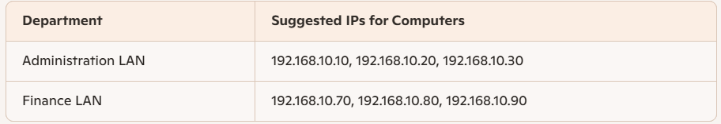
Note:
These are sample host IPs within each valid range. They can be assigned to PCs, printers, or other devices.

4️⃣ Default Gateway for Each LAN
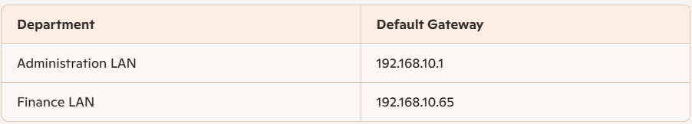
- Each LAN’s hosts use the router interface IP as their default gateway to communicate outside their subnet.
- The router routes traffic between the two LANs and to external networks.

